**Government Arts and Science College**

**Sankarankovil**

**Tenkasi - District**

**Machine Learning With Python**

**­­­­­­April - 2023**

**Predicting Personal loan Approval Using Machine Learning**

**Team Leader : Muralidharan S**

**Reg.No: (20201361506115)**

**Member 1 : Vasu M**

**Reg.No: (20201361506130)**

**Member 2 : Vairamuthu S**

**Reg.No: (20201361506127)**

**Member 3 : Vairamuthu S**

**Reg.No: (20201361506128)**

**Table of contents**

**1.Introduction Machine learning : 4**

**2.Overview of personal loan : 4**

**3.Problem definition : 5**

**4.Result : 6**

**5.Advantage & disadvantage : 8**

**6.Applications : 7**

**7.Conclusion : 9**

**8.Appendix : 10**

**Introduction of Machine Learning:**

Machine learning is a branch of Artificial intelligence and computer science which focuses on the use of data and algorithm to imitate the way that humans learn gradually improving its accuracy machine learning is broadly defined as the capability of a machine to imitate intelligent human behavior artificial intelligence system are used to perform complex task in a way that is similar to how humans solve problems Machine learning algorithm build a model based on sample data known as training data in order to make prediction or decision without being explicit programmed to do so that attributes contrast.

Machine learning algorithm are used in a wide variety of applications such as personal loan A subset of machine learning is closely related to computational statistics making a prediction using computer.

But not all machine learning is statistical learning machine learning programs can perform tasks without being explicit programmed to do so it involve computer learning from data provided so that they carry out certain task for simple tasks assigned to computers it is possible to program algorithm telling the machine how to execute all steps required to solve the program at hand on the computer part no learning is needed.

Machine learning is behind chat bot and predictive text, language translation apps, the shows Netflix suggests to you, and how your social media feeds are presented. It powers autonomous vehicles and machines that can diagnose medical conditions based on images.

When companies today deploy artificial intelligence programs, they are most likely using machine learning — so much so that the terms are often used interchangeably, and sometimes ambiguously. Machine learning is a subfield of artificial intelligence that gives computers the ability to learn without explicitly being programmed

The function of a machine learning system can be descriptive, meaning that the system uses the data to explain what happened; predictive, meaning the system uses the data.

**Overview of Personal Loan:**

Personal loans are formofinstallmentcredit. Unlike a credit card, a personal loan delivers a one-time payment of cash to borrowers. Then, borrowers pay back that amount plus interest in regular, monthly installments over the lifetime of the loan, known as its term. Personal loans are borrowed money that can be used for largepurchases, debt consolidation, emergency expenses and much more. These loans are paid back in monthly installments over the course of a few months or upwards of a few years.

A personal loan is an amount of money you can borrow to use for a variety of purposes. For instance, you may use a personal loan to consolidate debt, pay for home renovations, or plan a dream wedding. Personal loans can be offered by banks, credit unions, or online lenders. Most banks charge personal loan interest rates between 10.50% to 24% p.a. The interest rate that you are charged will vary based on a number of factors such as your credit score, your income, the company that you are employed with, your age at the time of applying for the loan, etc.

Personal loans may be secured or unsecured. A secured personal loan is one that requires some type of collateral as a condition of borrowing. For instance, you may secure a personal loan with cash assets, such as a savings account or certificate of deposit or with a physical asset, such as your car or boat. If you default on the loan, the lender could keep your collateral to satisfy the debt. An unsecured personal loan requires no collateral to borrow money. Banks, credit unions, and online lenders can offer both secured and unsecured personal loan.

**Personal loan prediction definition:**

* Collect the data sets there are many popular open source of collecting the data.

* As the datasets is downloaded let us read and understand the data properly with the help of some visualization.

* Our dataset format might be in CSV excel file, txt, etc… we can read the dataset of the help of pandas.

* In pandas we have a function called read CSV () to read the dataset we have to give the directory of the CSV file.

* For checking the null value insult () function is used to sum those null values we use .sum () function.

* From above code analysis that columns such as personal loan credit gender, married, dependent loan amount, loan amount term and credit history are having the missing values.

* Synthetic method over sampling technique will create a new synthetic data points for under class as per the requirement given by using KNN method.

* The sea born packages provide a wonder full function dis plot to make a multiple graph in a single plot we use a subplot.

* Models such as KNN logistic regression need scaled data they followed distance based method and gradient descent concept.

* For splitting training and testing data we are train test split () function from learn.

* Decision Tree Classifier algorithm is initialized and training the data is passed to the model with the .fit () function.

* Random Forest Classifier algorithm is initialized and training the data is passed to the model with the .fit () function.

Problem Definition & Design Thinking:

Empathy Map

An empathy map is a collaborative tool teams can use to gain a deeper insight into their customers. Much like a user persona, an empathy map can represent a group of users, such as a customer segment. The empathy map was originally created

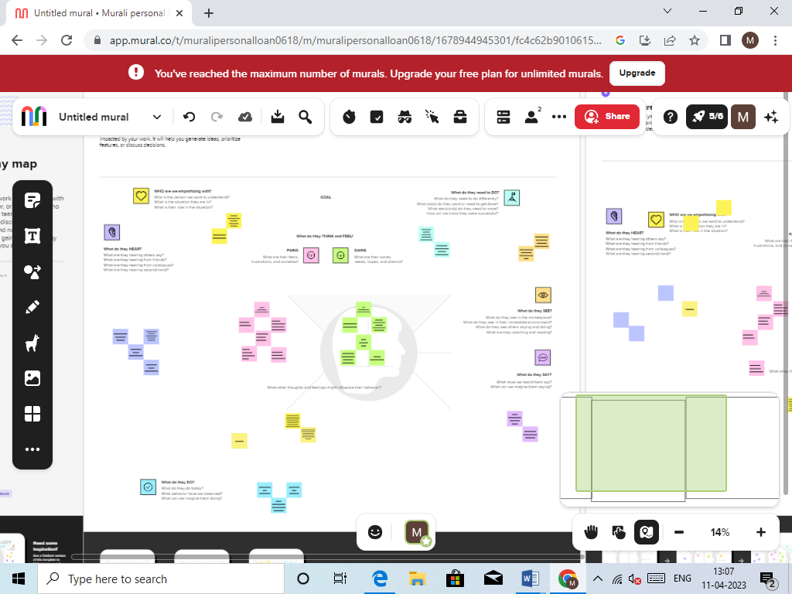

Ideation & Brainstorming Map

Unleash their imagination and start shaping concepts even if you're not sitting in the same room.

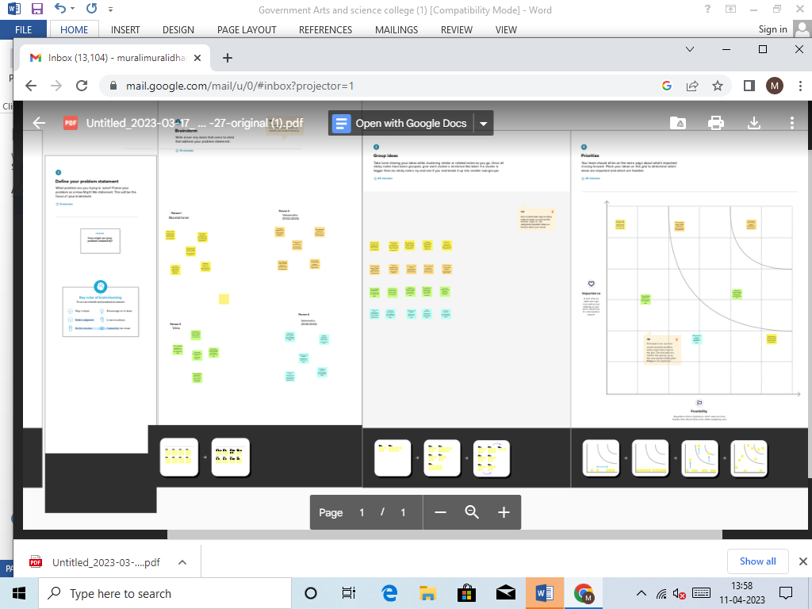

**Result**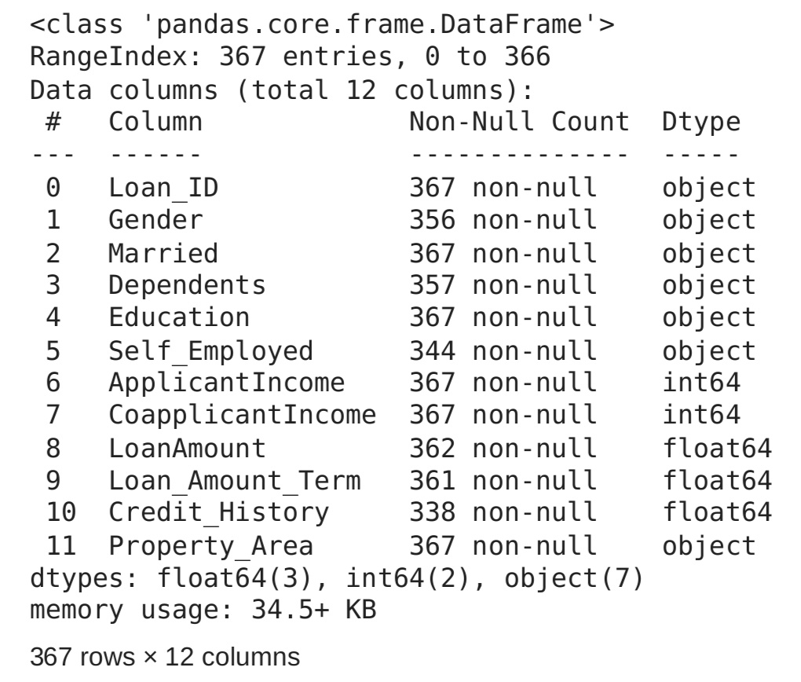

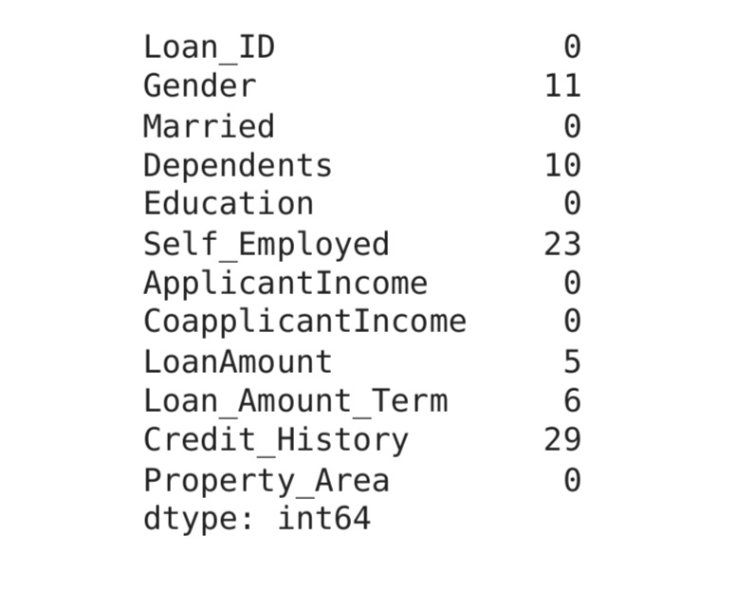

**Advantages &disadvantage**

* No limitation on end use the first and the most important benefit of personal loan is that unlike home loan it can be used for any purpose.

* If you meet the eligibility criteria and have a good credit score get personal loan 74 hours.

* Some of the bank provide the facility of online approval of personal loan for existing customer.

* No collateral required you don’t arrange for any collateral it is an unsecured loan therefore it is easy to get it.

* Flexibility to choose the tenure of the loan goes up to 7 years therefore you have flexibility to chosen a tenure.

* Fixed rate of interest personal loan is generally available of fixed rate of interest.

* Tax benefit money has been utilized.

* Pros of personal loan can offer benefit over other types of loans a few advantages of using this type of financing over other options.

* Fast funding time personal loan generally have fast approval times and payment times making.

* Some personal loan lenders can deposit the loan proceeds to your bank account as soon as the nest business day.

* No collateral requirement personal loan don’t require collateral for you to get approved.

* The loan based on the agreed upon terms with your lender face significant financial and credit consequences.

* Lower interest rate personal loan often come with lower interest rates.

* You may also qualifier for a higher loan amount than the limit on your credit score.

Applications:

* Consider a step down EMI plan a step down EMI payment decreases every year during the stipulated loan tenure.
* A value of a personal loan top up with lower interest rates.
* Personal loan are a good way to consolidates and pay off costly credit card debit.
* They help you pay for emergency expense without draining your savings.
* They enable you to consolidate high interest rate debt.
* You can use them to finance your wedding or dream vacation.
* A personal loan they have predictable payment schedules.
* A personal loan are flexible in there user for approved.
* Debt consolidation is used for loan.

**Conclusion:**

* Loan for the long term unlike payday loans the personal loan is availed for a long term and the interest rate is low here it comparison to the home loan.

* No collateral security have to give any security or mortgage the property for availing this loan.

* No strict documentations requirements is minimal requirement for personal loan.

* Comes with scheme at occasions leaders keep announcing special offers and schemes for personal loan.

* Insurance coverage some type of personal loan are available with additional benefits such as personal loan with insurance coverage.

* Expect as amended and modified hereby, any and all of the terms and provisions of the Loan Agreement and the other Loan Documents shall remain in full force and effect and are hereby in all respects ratified and confirmed by Borrower.

* Borrower hereby agrees that, except as expressly provided in this Amendment, the amendments and modifications herein contained shall in no manner affect or impair the liabilities.

*duties and obligations of Borrower under the Loan Agreement and the other Loan Documents or the Liens securing the payment and performance thereof. Borrower further confirms that the liens and security interests in the Collateral created under the Loan Documents secure, among other.

Future scope:

* Personal loan market size is growing at a faster pace with substantial growth rates over the last few years and is estimated that the market will grow significantly in the forecasted period.

* You might be able to borrow more than with a credit card.

* On larger balance they usually charge a lower rate of interest when compared with a credit card or other forms of credit.

* Your loan repayment will usually be a fixed amount each month can make to easier budget.

* Loan maturity date refers to the date on which a borrower s final loan payment is due.

* Maturity value is the amount due and payable to the holder of a financial obligation as of the maturity date of the obligation.

* Personal loans account for about 96% of the new bank loans during FY 2018.

* It won’t be wrong to say that the personal loan sector is growing with every passing day and will continue doing so.

* With digitization in almost everything today, a personal loan has become accessible to almost everyone. There has also been a sharp increase in the number are making it simpler for every individual to get these loans._­­­

**Appendix:**



